MACH4METAL

metalworking machinery
Transito 21
6909 DA BABBERICH Netherlands
Tel. +31 (0)316-247123
Fax: +31 (0)316-247956
info@mach4metal.com
www.mach4metal.com

Bank No : 66.52.13.883
IBAN : NL33 INGB 0665 2138 83
BIC : INGBNL2A

LVD PPEB EFL 4500 x 320 T
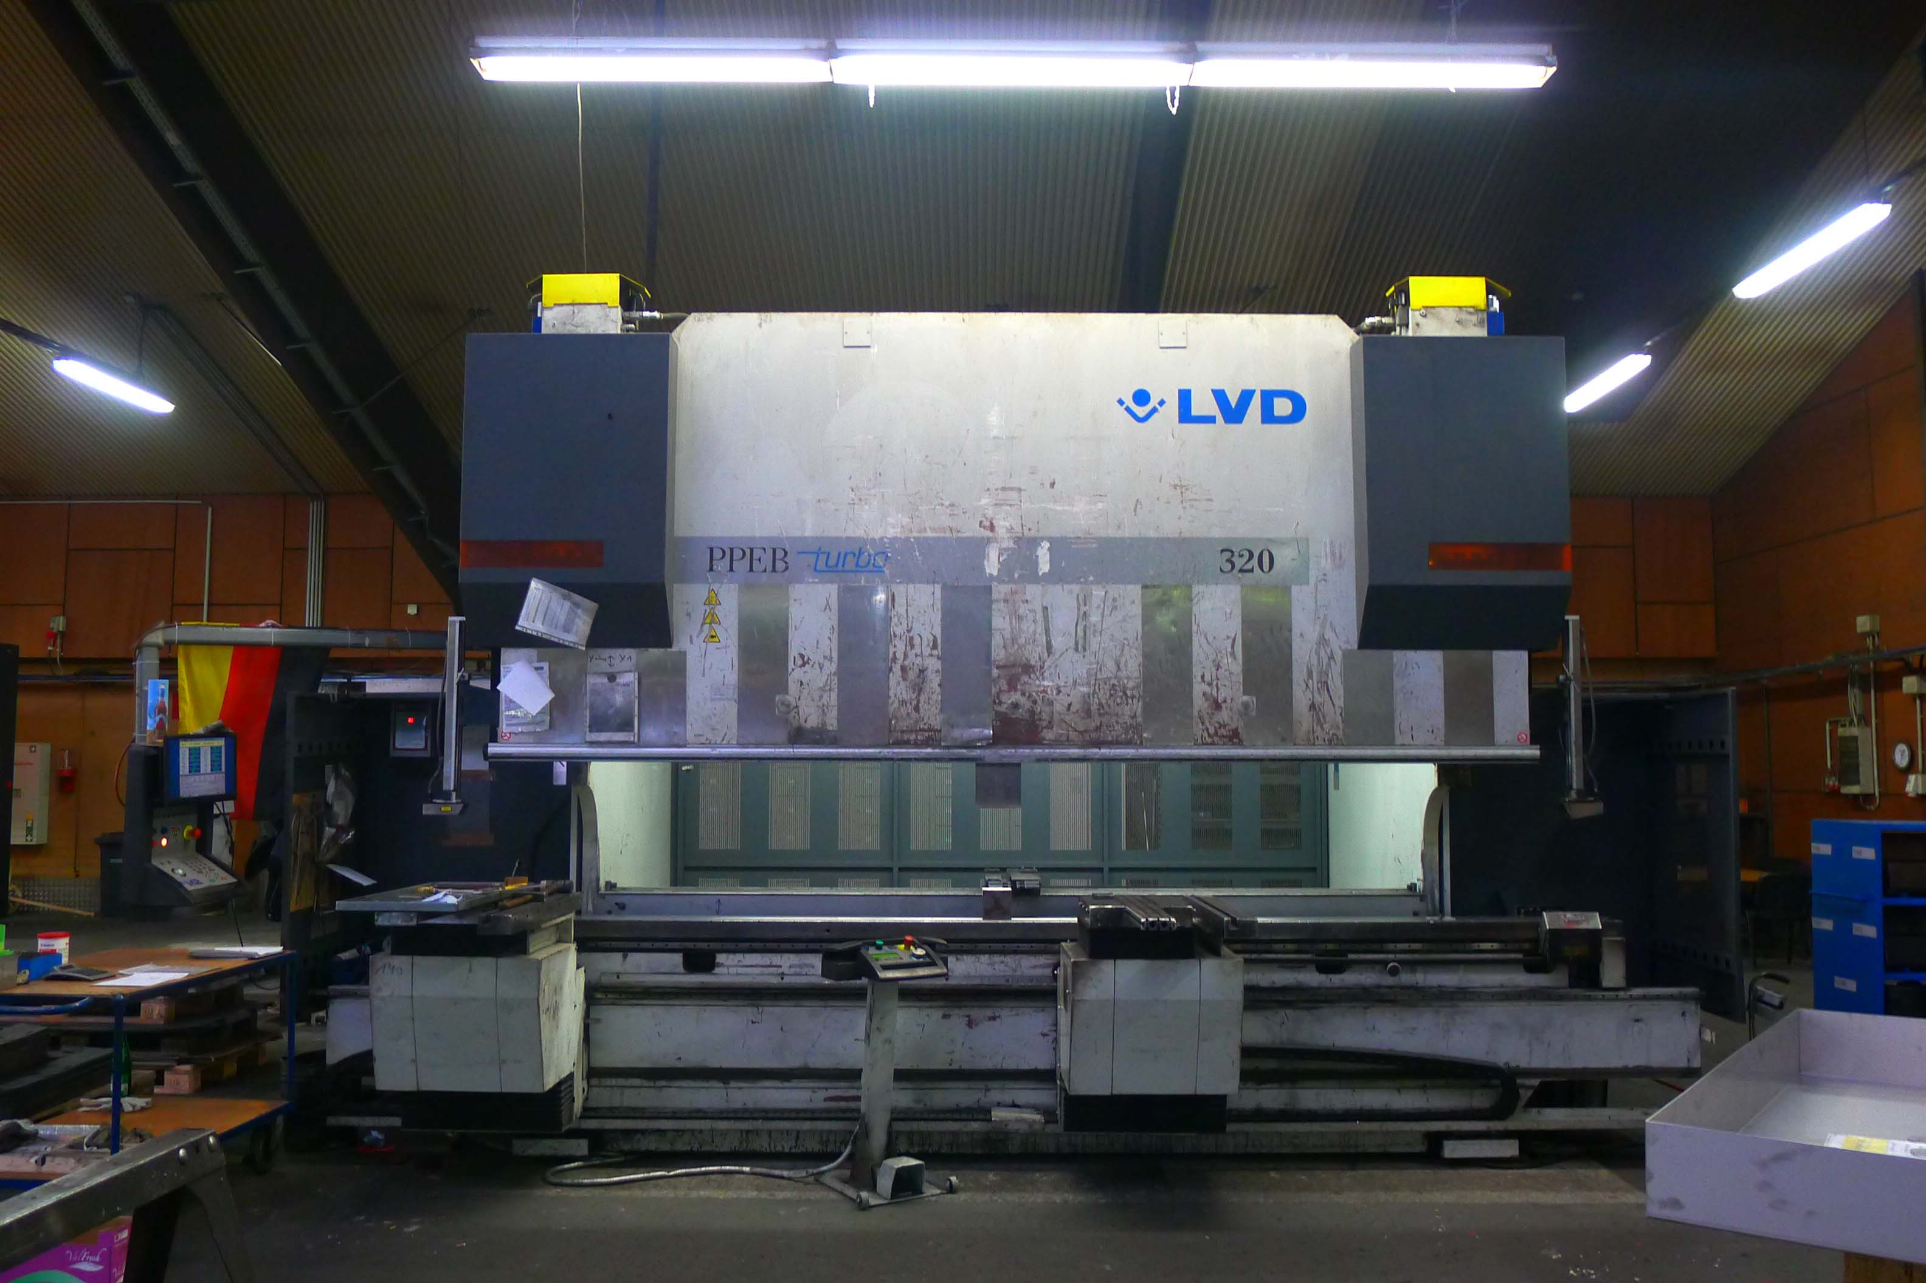
- Make : LVD - Belgium
- Typ : PPEB 320/4500
- No :
- Age : new 2005

- Max. bending length: 4.500 mm
- Between column : 3.820 mm
- Max. force : 320 Ton

- Dis. Beam – table : 670 mm
- Beam stroke : 400 mm
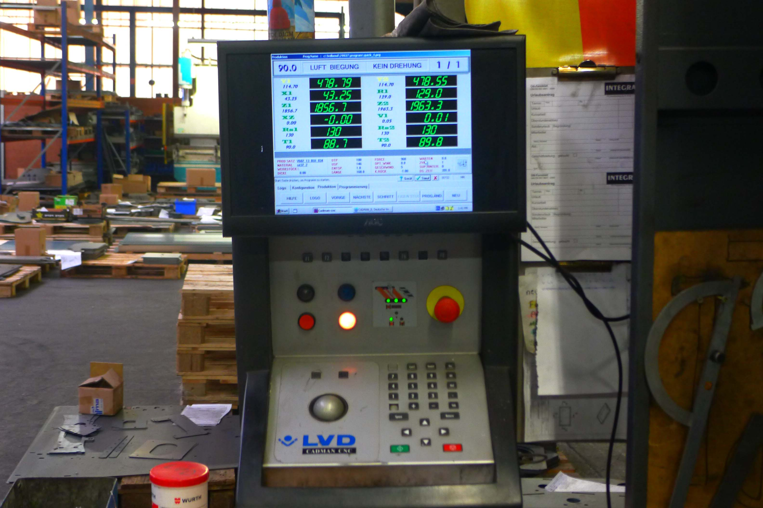
- Table width : 200 mm
- Troth beam : 400 mm

- Approch speed : 100 mm/min
- Bending speed : 11 mm/min
- Return speed : 100 mm/min

- CADMAN CNC in 8 Axis
- EFL Easy form angle measuring system
- CNC Bending arm T¹ and T²
- WILA new 2 hydraulic tool clamping
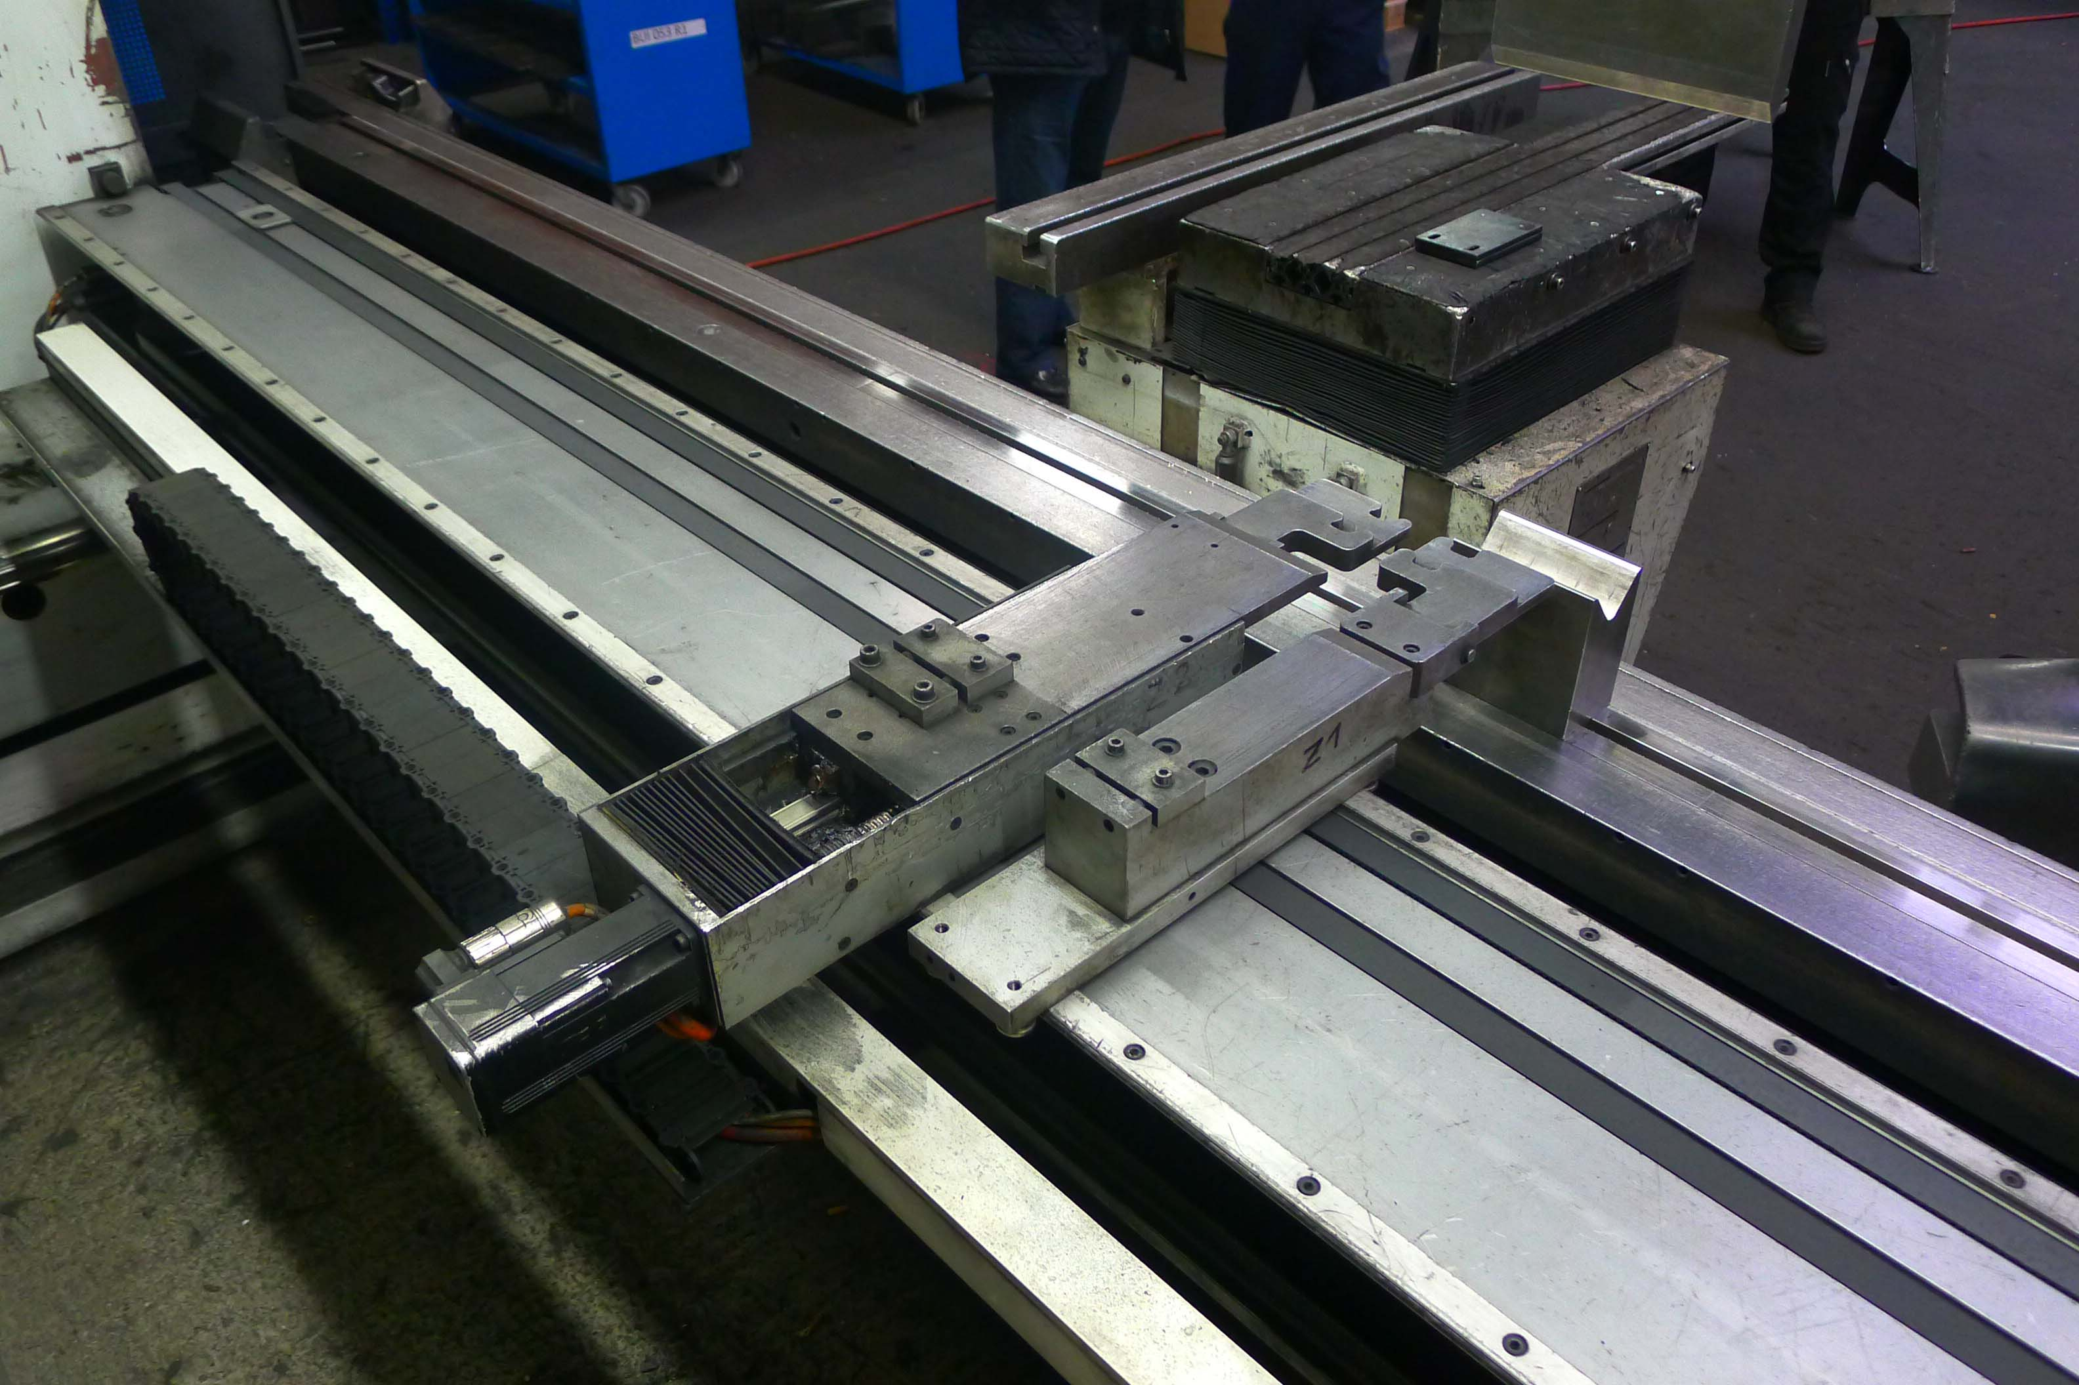
- Dimensions
- Length : 6.740
- Width : 3.200
- Height : 3.850
- Weight : 28.000 Kg
- Power : 37 kW

- Machine is not embedded !
- Build over Floor !

Please Note: The above information has been obtained to the best of our ability and belief from, and from the manufacturers where possible. It is given in good faith, but its accuracy can not be guaranteed. Accordingly, it will not form a representation or constitute contractual terms. We advise you to check any vital details!

